COLD ASHBY VILLAGE HALL
Main Street, Cold Ashby NN6 6EL
Charity number 1024816
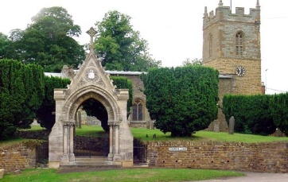
Committee Meeting

Tuesday 21st May, 2019: 7.30 p.m.

Minutes

- Minutes of meeting on 19th February 2019: to be read in August
- Matters arising:
- Apologies for absence: S Taylor
- Chairman’s report: thanks to RB for installing blind. Curtains to be removed
- Finance:
- Monthly accounts March-May: updated accounts for May were approved
- £30 lottery loss: treasurer explained the matter: £30 written off.
- Electricity improvements: general approval. Hidden heater switches revealed.
- Activities and usage update:
- Luncheon club (CS) – bins to be placed on footpath – KG to undertake
- Cycling – polling station
- Centenary activities 2020: agreed small group to coordinate activities: RB, RM, KG, CS. To meet in Village Hall.
- AOB – Felt roof on shed. Paul Gardham requested to purchase and repair – receipt to treasurer for reimbursement.

G Jones, Secretary May 2019

